GITHUB REPO - REPO LINK

Modeling Human Activity States Using Hidden Markov Models

1. Background and Motivation
Human activity recognition is the task of classifying a physical activity of a human subject based on sensor readings. There are numerous applications of human activity recognition, such as fitness tracking, contextual mobile apps and monitoring everyday human movements. Current smartphones have built-in accelerometers and gyroscopes which allow collecting movement data without using any additional wearable devices.
In this project, an application of Hidden Markov Models (HMM) to classify four human activity states based on smartphone sensor data is studied: standing, walking, jumping and sitting. Despite the similarity of the first two, walking and jumping involve different movements. Being able to classify those four activities is a good way to study how features of the sensor observations and probabilistic models of sequences can detect human activities.
The HMM model was chosen since sensor observations depend on time and thus can be considered as sequences generated by some hidden states. Therefore, both statistical properties of the sensor data and the transitions between hidden states will be studied.
The aim of the project was to obtain, pre-process and feature-extract accelerometer and gyroscope sensor data and apply an HMM to the activity states.

2. Data Collection and Preprocessing

2.1 Data collection
The dataset was acquired through the use of the Sensor Logger smartphone application. The sensor data recorded include the x, y, z values for the three-axis accelerometer and the three-axis gyroscope. The timestamps and elapsed time information have been recorded as well.
There are four different activity classes included: standing, walking, jumping, and remaining stationary. There are 200 activity samples in the dataset, with each class having 50 samples. Each sample was archived as a zip file that includes the sensor and metadata CSV files. The sensor sampling rate was 100 Hz (about 100 measurements per second).
Four activity video clips have been captured as well.

- Standing: STANDING VIDEO LINK
- Walking: WALKING VIDEO LINK
- Jumping: JUMPING VIDEO LINK
- Staying still: STAYSTILL VIDEO LINK

2.2 Data quality checks and preprocessing
The data were inspected before model training to check file availability, sensor columns, missing values, duplicate elapsed timestamps, and recording duration. Empty optional annotation and uncalibrated-sensor files were handled without preventing the main sensor files from being processed. The primary accelerometer and gyroscope CSV files were used for analysis.
The recordings were mostly approximately 10–13 seconds long. Although the assignment rubric specifies recordings of 5–10 seconds, the collected recordings were retained for processing because the main sensor data were readable and passed the implemented quality checks. This duration difference is acknowledged as a limitation against the stated recording-length criterion.

2.3 Windowing and feature extraction
Sensor signals were processed using a sliding window approach with a size of 2 seconds and a stride of 1 second, making the overlap between consecutive windows to be 50%. Considering a frequency of 100 Hz, in each 2-second window, there are approximately 200 observations from one sensor. Windowing technique was chosen due to being a reasonable trade-off between having enough measurements for estimating movement features and possibility of analyzing activity patterns over time. Using a stride of 1 second allows to increase the number of training samples without need for further data recording.
For aligning accelerometer and gyroscope signals, their shared time range was used. Windows containing less than 100 measurements from any of the sensors were removed. In total, 1,925 windows were extracted from all 200 recordings in the created pipeline, no recordings were ignored.
Feature candidates include axis mean, standard deviation, variance, RMS value, magnitude, dominant FFT frequency, and spectral power. The final model consists of 20 features chosen from each sensor: axis mean and standard deviation, magnitude mean and standard deviation, dominant frequency, and spectral power. Redundant variance and RMS features have been excluded from the final feature set.
The time domain features measure the signal amplitude and variation, while frequency domain features measure the frequency information of the movement pattern. This combination enables the model to utilize both intensity and periodicity of the recorded activities.
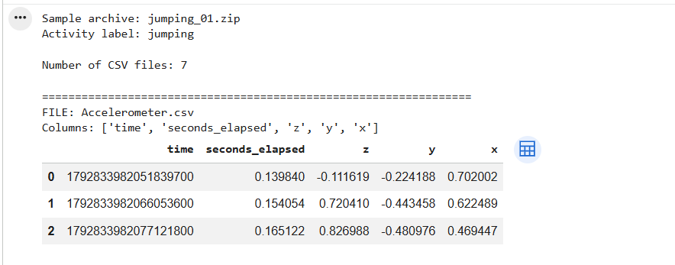
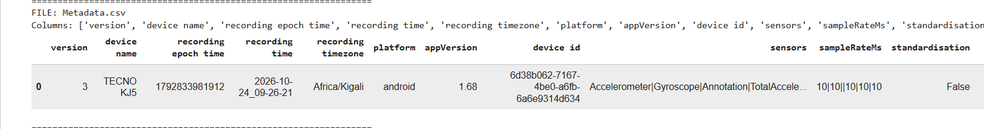
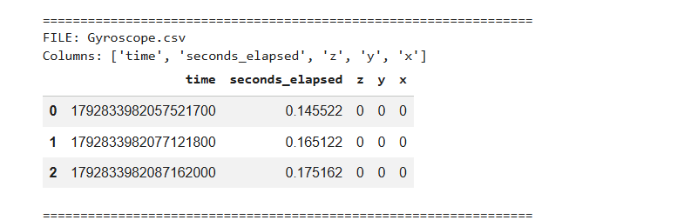
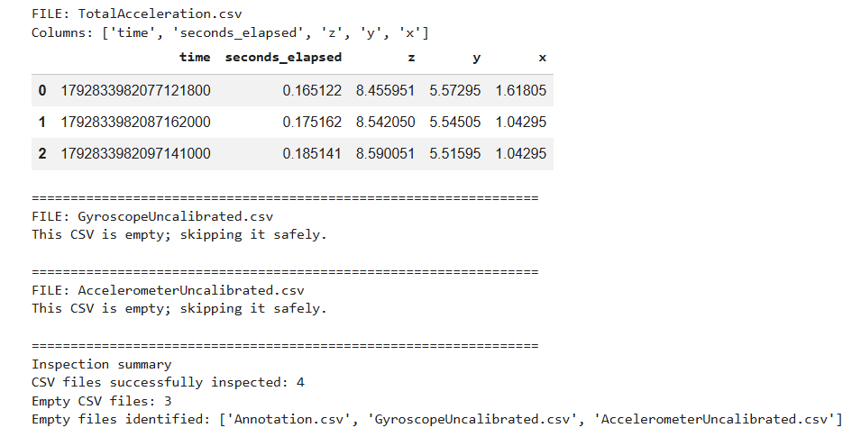
Figure 1. Examples of raw smartphone sensor measurements for the four activity classes.

3. HMM Design and Implementation

3.1 Training and normalization
The dataset was split by recording rather than randomly splitting individual windows. For each activity, 48 recordings were used for training and two were reserved for testing. This produced 192 training recordings and eight held-out test recordings. Splitting by recording helps prevent overlapping windows from the same original recording appearing in both training and testing data.
The selected features were standardized using z-score normalization. The scaler was fitted only on the training data and then applied to the test data. This prevents information from the held-out test set from influencing the normalization parameters.

3.2 HMM architecture and training
A separate three-hidden-state Gaussian HMM was trained for each activity class. Each model represents sensor-feature sequences using an initial-state distribution, a state-transition probability matrix, and Gaussian emission distributions. The hidden states represent recurring statistical patterns in the sensor data; they should not be interpreted as verified physical stages of an activity.
The models were initialized using K-means clustering and trained using the Baum–Welch algorithm, an expectation-maximization procedure that estimates HMM parameters from observation sequences. A maximum of 20 iterations was permitted, with a convergence tolerance of (0.01) and a variance floor to reduce numerical instability.
Each original recording was treated as a separate sequence during training so that unrelated recordings were not joined into artificial continuous sequences. Log-likelihood histories were recorded to monitor training progress.

3.3 Decoding and classification
The Viterbi algorithm was implemented to identify the most likely hidden-state sequence for an observation sequence under a given HMM. For activity classification, each test recording was evaluated against the four trained models. The model with the highest average log-likelihood per window was selected as the predicted activity.
Average log-likelihood was used to make scores more comparable across recordings containing slightly different numbers of windows.

4. Results and Evaluation
The trained models were evaluated on eight held-out recordings, comprising two recordings from each activity class. Six of the eight recordings were classified correctly, giving an overall recording-level accuracy of 75%.
Activity | Correct predictions | Sensitivity | Specificity
Standing | 1/2 | 50% | 83.33%
Walking | 1/2 | 50% | 83.33%
Jumping | 2/2 | 100% | 100%
Staying still | 2/2 | 100% | 100%
Sensitivity measures the proportion of recordings from a class correctly identified. Specificity measures the proportion of recordings from the other classes correctly rejected. These results indicate that jumping and staying still were correctly classified in both test examples, while standing and walking were each confused with another activity once.
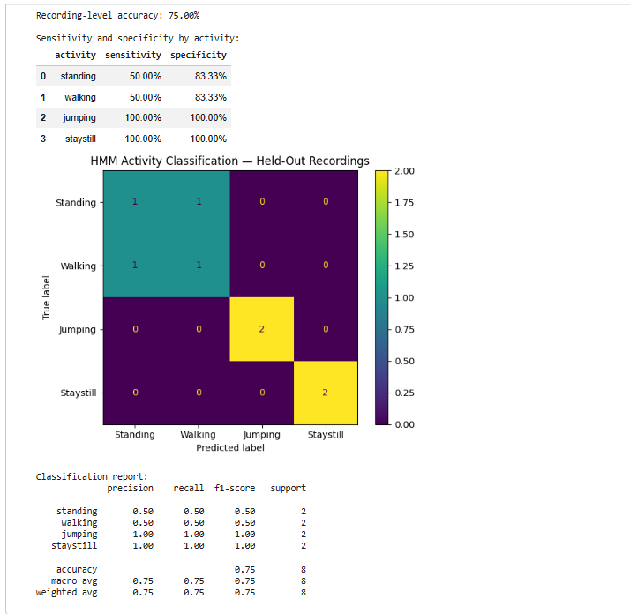
Figure 2. Confusion matrix for the eight held-out recordings.
The transition-probability heatmaps show the learned probabilities of moving between hidden states within each activity model. The Gaussian emission-mean heatmaps illustrate how the hidden states differ across the standardized sensor features.
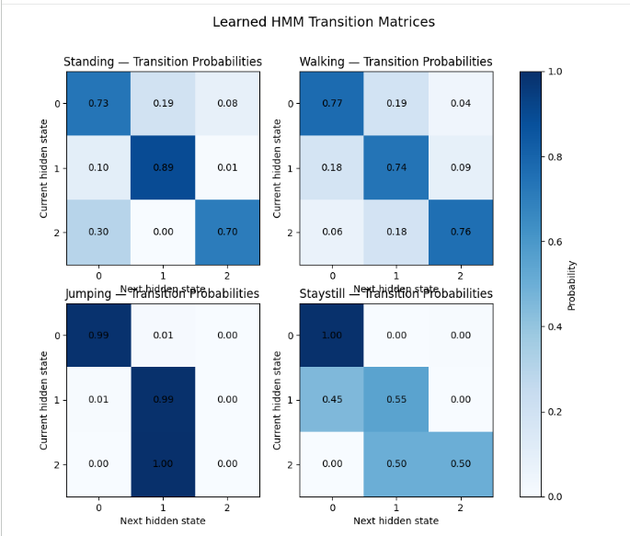
Figure 3. Learned hidden-state transition probabilities for the four activity models.
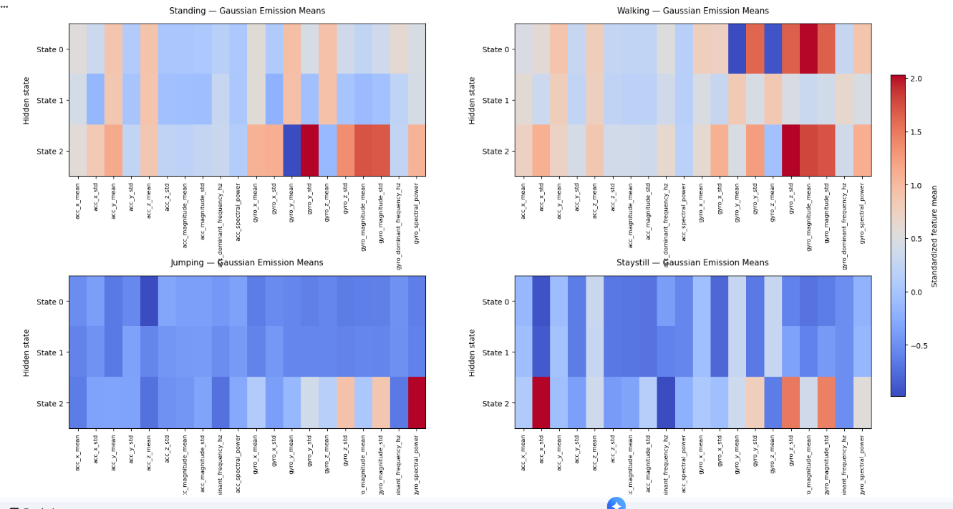
Figure 4. Standardized feature means associated with the hidden states of each activity model.
The training histories showed that the jumping and staying-still models met the stopping tolerance within the allowed iterations. The standing and walking models reached the maximum of 20 iterations without meeting the specified convergence tolerance. Their results should therefore be interpreted with this training limitation in mind.

5. Discussion and Conclusion
The current project presents an example of a full cycle of human activity recognition from the data captured by a smartphone's accelerometer and gyroscope sensors. This cycle involves data quality verification, windowing, feature extraction, training normalization, Gaussian HMM training, Viterbi decoding, and evaluation based on the unseen recordings.
The achieved 75% test accuracy rate looks promising, however, it should be considered provisional due to the small number of test samples per each activity - just two. Two perfectly recognized jumping and sitting activities cannot prove the model's capability to operate successfully with other subjects or recordings. Confusion between standing and walking can result from the similar properties of the chosen features, different positions of the phone or lack of the test data.
Another limitation is that the duration of the recording was not equal to what is specified in the rubric (5-10 seconds). Also, in two cases, the HMMs were not able to converge under the 20 iterations limit. In future, one may want to analyze more unseen recordings, try other combinations of features and numbers of states, and also examine the effect of different recording sessions.

In summary, the project managed to build and analyze the HMM-based activity classifier successfully. It was shown that the selected features of the sensors are informative enough to distinguish between four activities, but it still shows the importance of using larger test sets and doing additional analysis.

